 | Application for Europe Netball C & B Award Re-endorsements | 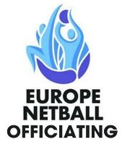

To apply for the Re-endorsement of your current award, please complete this application form in full before submitting by email to Swiss Netball at cawardpractical@swissnetball.ch and copy officiating@swissnetball.ch

Please attach a copy of your Logbook in support of your application.

Umpire name: |  |  | Date of birth:
Email: |  |  | Swiss Netball Individual Membership No.:
Address:

Tel: |  |  | Mobile:
Current Award to be re-endorsed:
Date of Practical assessment of current Award:
Duration (months) since being previously active as an umpire:
If you have had mentoring, please give your Mentor’s name:
Date of submission:
Date form is received and information checked by Swiss Netball:
Note: The fee to re-endorse is 40 CHF. Payment is to be made to Swiss Netball no later than 7 days prior to taking the Practical Assessment.

 | Application for Europe Netball C & B Award Re-endorsements | 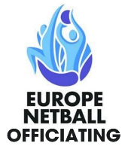
Notes:
- Once an application is received, the practical assessment will be arranged as soon as possible and within 3 months (unless there are extenuating circumstances)

Applicants must:
- Previously have qualified as a Europe Netball C or B Award umpire.
- Entered evidence of umpiring experience in the Logbook in preparation of the re-endorsement.

Assessors:
- Two currently accredited Europe Netball Umpire Assessors will conduct the practical assessment
- Each Assessor will assess the Umpires independently and the result will be determined after thorough discussion between the two Assessors

Form of Assessment:
- C Award Umpires will be observed for a minimum of 30 minutes competitive match play (2 x 15 minutes). B Award Umpires will be observed for a minimum of 48 minutes competitive match play (4 x 15 minutes).
- Umpire must refer to the Europe Netball Umpire Competencies to understand what is required from them to pass their re-endorsement.
- Umpies will receive a short, concise verbal feedback post-assessment and will be informed of the overall result as a Pass or Not Yet Met Criteria (NYMC). Umpires will receive a written report (LARF) within 7 days of the assessment.
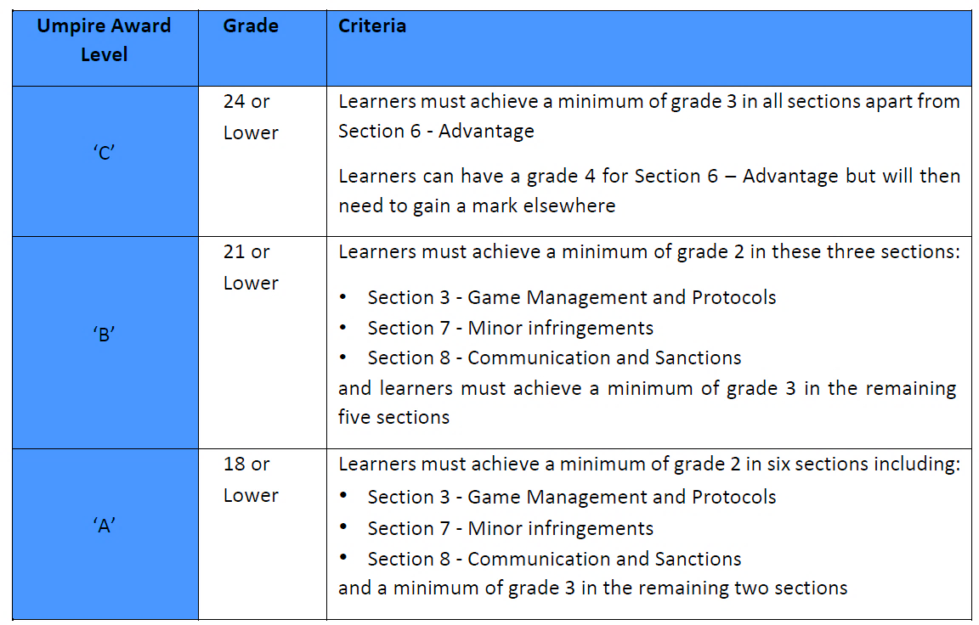

Results:
- The names of the successfully re-endorsed umpires will be added to the Swiss Netball Umpires Register.
- Umpires should retain a copy of the eLARF that is sent to them and if required, use to prove validity of their Award.
- Any umpire who is not successfully re-endorsed (NYMC) is able to re-take the re-endorsement after 2 months.

